Souvik Barua 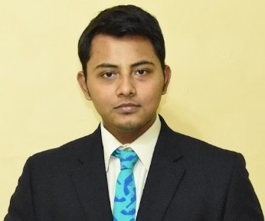
Kolkata, West Bengal, India

linkedin.com/in/souvikbaruair
souviktubaiz20@gmail.com 7980151912

Summary
UGC- NET Qualified and JRF awardee , MPhil & Master's degree holder in Political Science and International Relations respectively from Jadavpur University. My area of interests are Political theory, International Relations which IR theory, foreign policy and International politics.

Experience

Tutor for Intermediate to Post Graduate Students on Political Science and International Relations

Quest 4 Excellence
2019-2022

Education

Jadavpur University

M.Phil., International Relations
- – 2021 (Dissertation submitted in Jun 2022, delayed in post covid scenario)

University Grants Commission (UGC)

JRF Awarded NET Qualified in Political Science November 2022

University Grants Commission ( UGC)

NET Qualified , Political Science
2019

University Grants Commission ( UGC)

NET Qualified , International Relations and Area Studies
2019

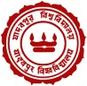 Jadavpur University, Kolkata

Master of Arts - MA, Political Science and International Relations
2017 – 2019 (First Class)

Jadavpur University, Kolkata

Bachelor of Arts - BA, Political Science
2014 – 2017
ISC ( Indian School Certificate Higher Secondary Board Exam
First Class from St. Joseph Mary’s School 2014
CBSC ( Central Board of Secondary Education )
From DAV Public School , Nerul , Navi Mumbai 2011

Licenses & Certifications

Certificate of Participation in Kolkata Colloquium 2019 on Re imaging BITMSEC 2019 -

Observer Research Foundation

Seminar on Human Rights - Jadavpur University - 2014
P
C

Participation of International Relations Scholastic Conclave -2015 - Jadavpur University
Certificate of Participation in YESM ( Young Economist Student's Meet 2018) - Jadavpur University
Certificate of Participation in the seminar on contemporary South Asia - Maulana Abul Kalam Azad Institute of Asian Studies and Jadavpur University -International Relations Dept
International Relation Scholastic Conclave 2014 - Jadavpur University
Certificate of Participation on SLP 'BREXIT AND THE WORLD AFTER TRUMP - The Jadavpur Association of International Relations

Personal Information
Date of birth : 20 March 1995
Father’s Name : Biman Barua
Permanent Address : C/ o Biman Barua , Flat 197 Block 32 , Parnasree Govt Qtrs .
Behala , Kolkata - 70060

Skills
Communication Skills • Critical Thinking • Patience • Coaching • Organizational & Writing Skills • Team Building .

